**Swordfish Developer Documentation**

Contents

1) Overview:- 1

2) Steps to create Power Bi Dashboard:- 2

# 1) Overview:-

A Power BI dashboard is a single page, often called a canvas that uses visualizations to tell a story. Because it is limited to one page, a well-designed dashboard contains only the most-important elements of that story.

Install the downloaded Powerbi.msi in your own desktop then our source will be JSON web service That’s why developer use web as a data source as shown in the below figure.

# 2) Steps to create Power Bi Dashboard:-

Step1:- Open Power-BI Desktop and click on “Get Data” and click on web button.

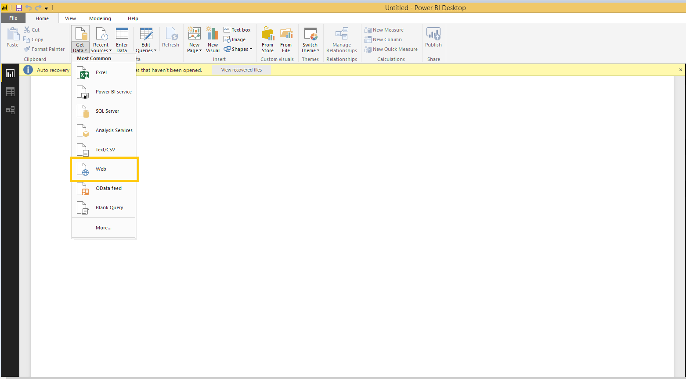

Step2:- After clicking on web button it will display the Basic and advanced URL path tab as shown in the below figure.

* URL means Uniform source locator.

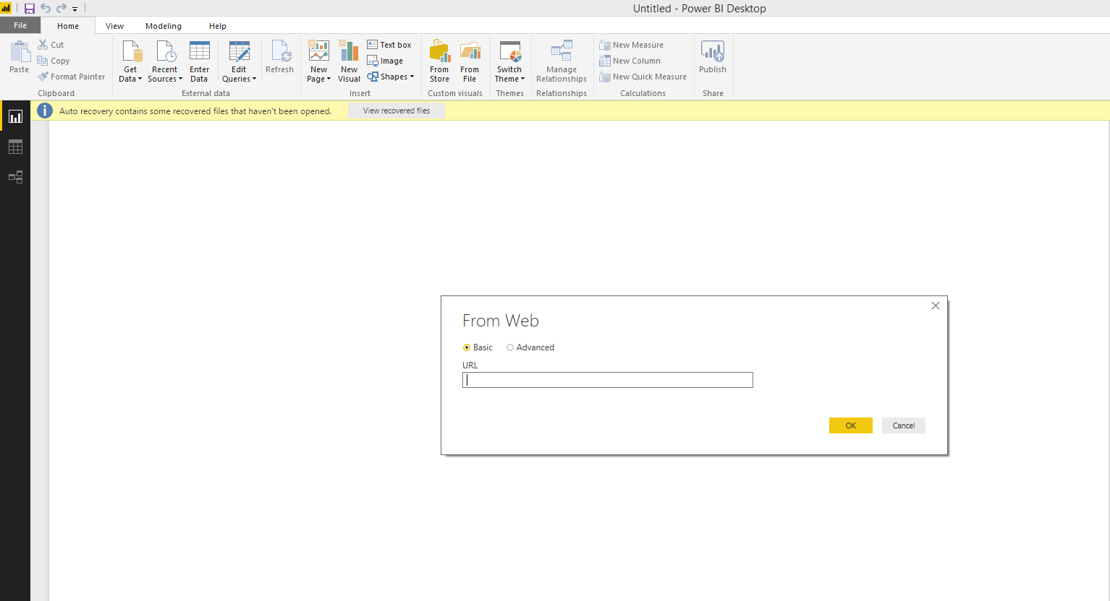

In the URL-tab place will give the URL as a data source by giving below example.

Eg:- [http://localhost:5000/redfish/v1/StorageServices/1/StoragePools /sp1](http://localhost:5000/redfish/v1/StorageServices/1/StoragePools%20/sp1)

Step 3:- After placing the URL in given tab it will automatically go to query editor as shown in the below figure

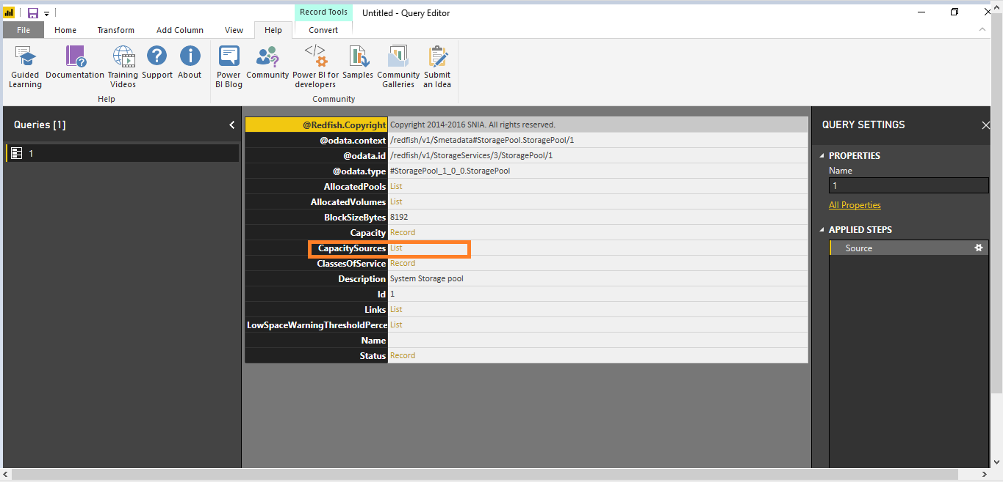

When click the capacity sources of list button it will open the list of records as shown in the below figure.

Step 4:-

Open the list of records, click on the Record button as shown in the above figure. It will show nested service.

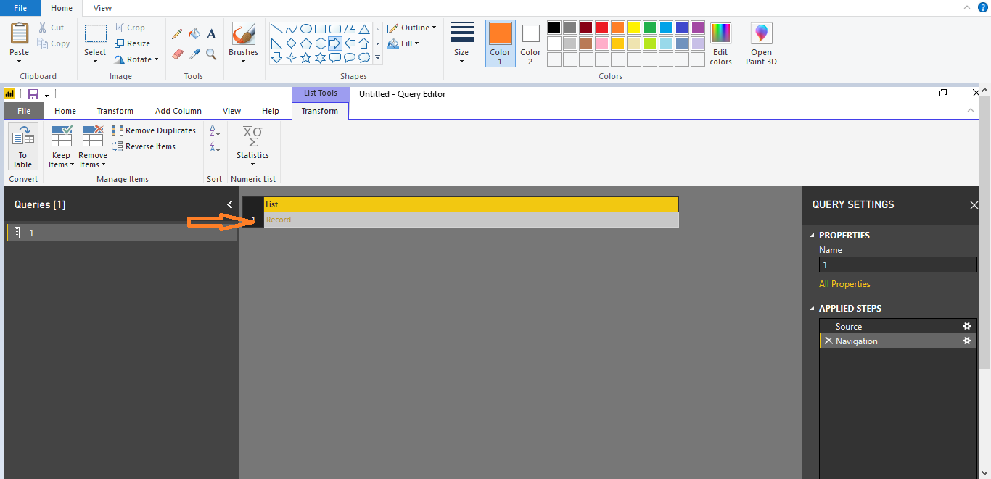

Step 5:-

After click on provided capacity records it will show the all capacities of provided capacity array as shown in the below figure

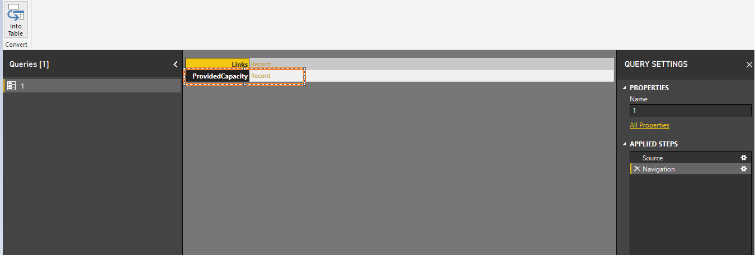

Step 6:-

The below figure shows all Provided capacity of array records

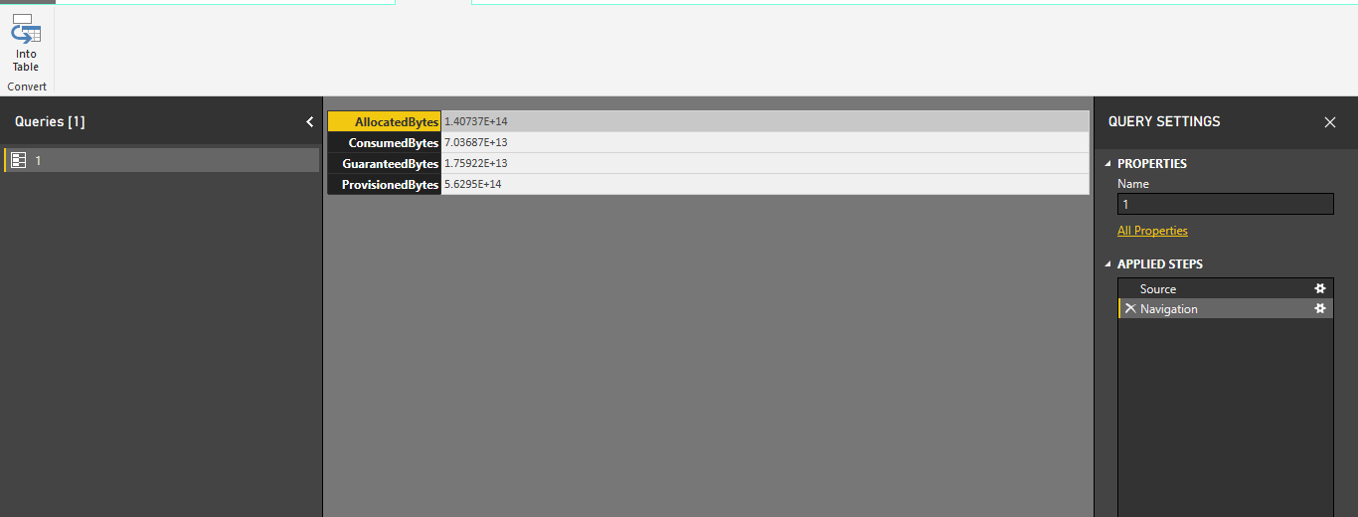

Step 7:-

After showing the all capacities values converted those into table by clicking ”intotable”option placed in the left side button as shown in the below figure.

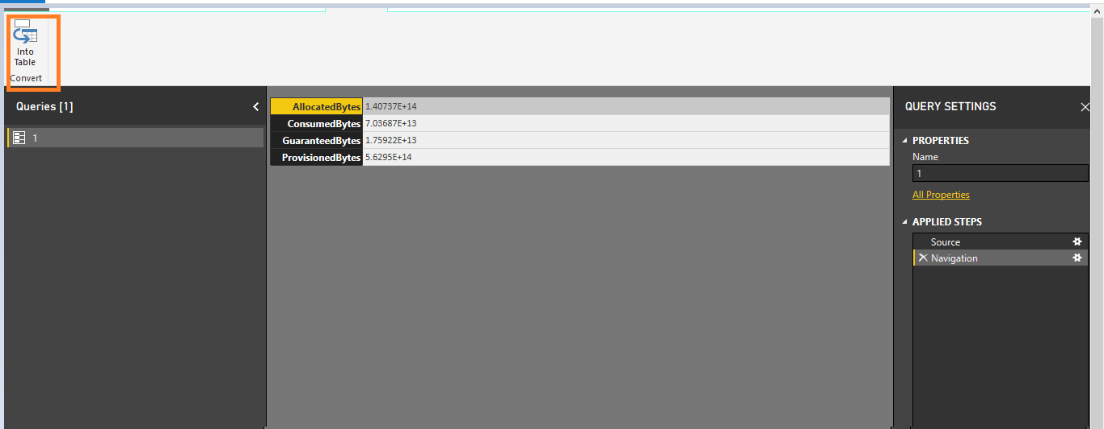

Step 8:-

After Clicking “into table” button the format of the values are converted into table as shown in the below figure.

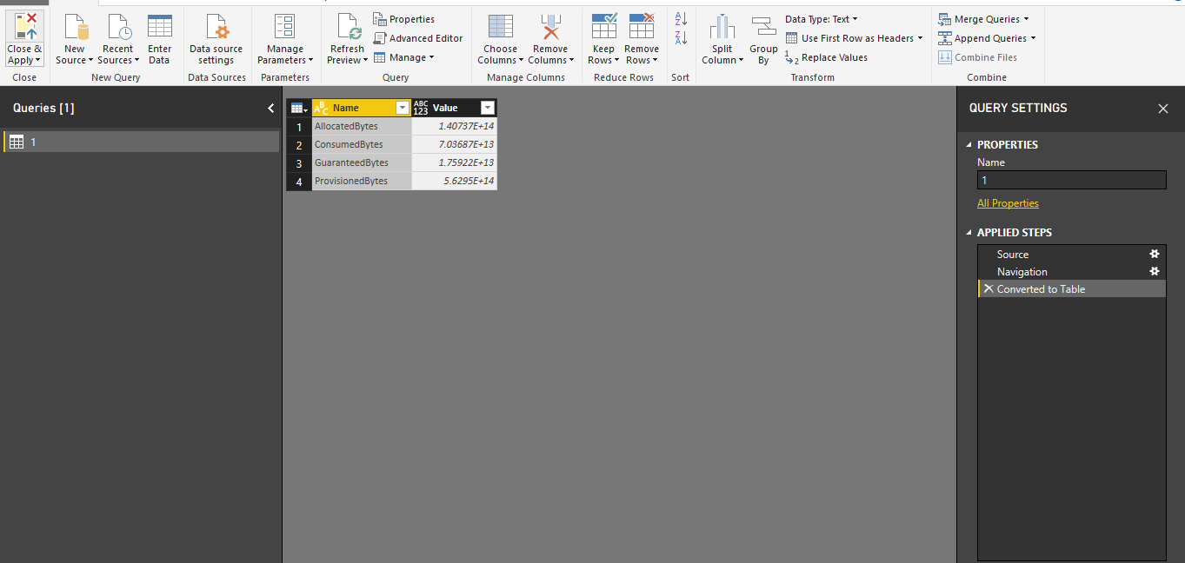

Step 9:-

The next step is go to the transform button in the Menu-Bar click on Transpose button then columns will change to rows as shown in the below figure.

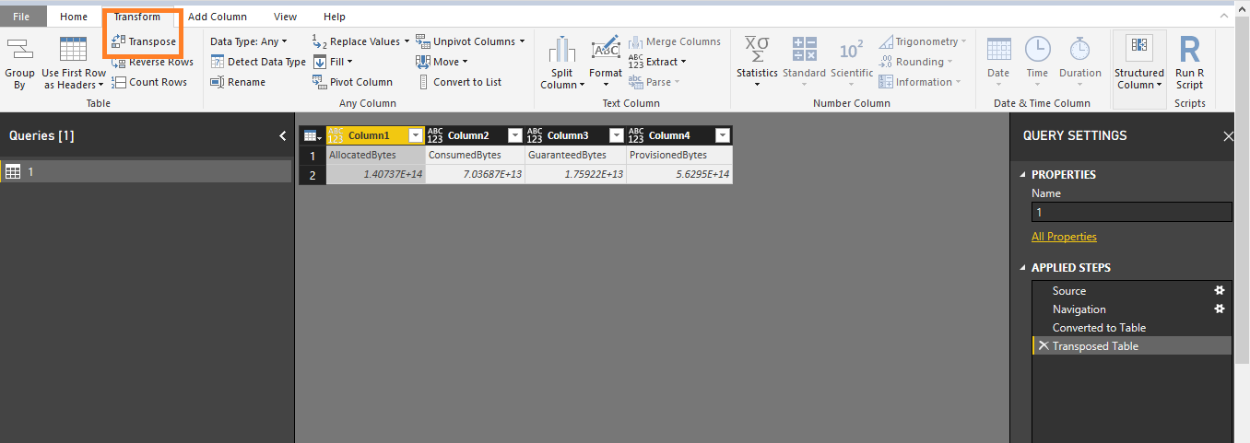

Step 10:-

Go to Transform button of Menu bar and click on “use first row as headers” the columns of the first row filled with the table first row .

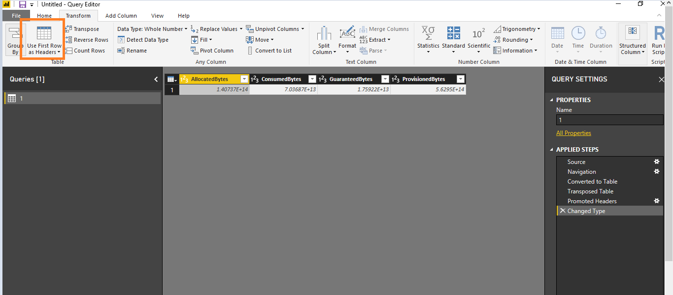

After click on use first row button the output will be shown in the above figure and remove the the guaranteed bytes and provisoned bytes Columns if don’t need.

Step 11:-

The next step is remove the guaranteebytes and provisoned bytes go to home button and “ click&Apply “button as shown in the below figure.

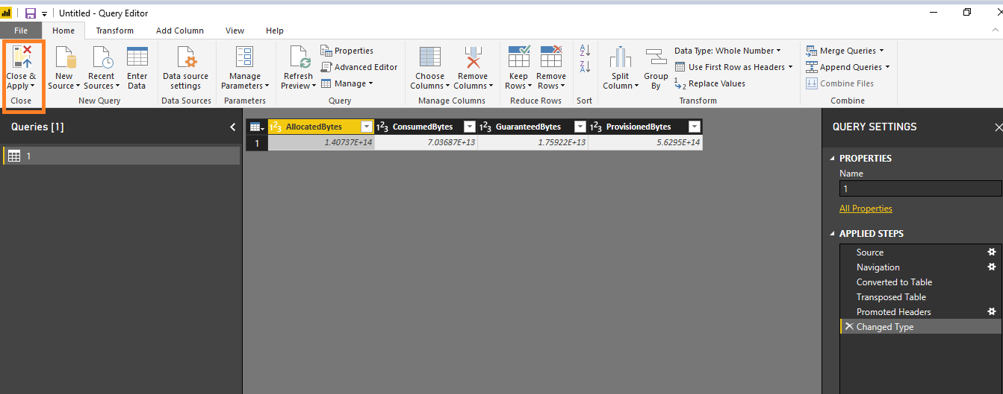

It will go the visualization page of power bi.

Step12:- After completion of step1 to step11 developer wants to take Sub-URL of Storage Pools and follow below steps accordingly.

**Eg :-** <http://localhost:5000/redfish/v1/StorageServices/3/StoragePools>

Go to “Getdata” and click on web as a datasource as same as step1&2 and give the above URL.

Give the above URL into URL-tab and it will open the Editor window as shown in the below figure and follow accordingly.

Step13:- After open the editor window will click on the Members list and Storage Pools sub-Records will be shown in below figure.

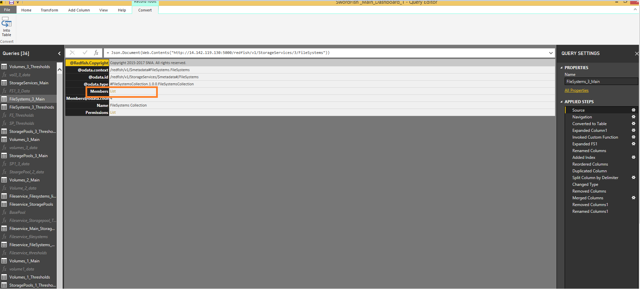

Step 14:-

Members will navigate into records list as shown in the below figure

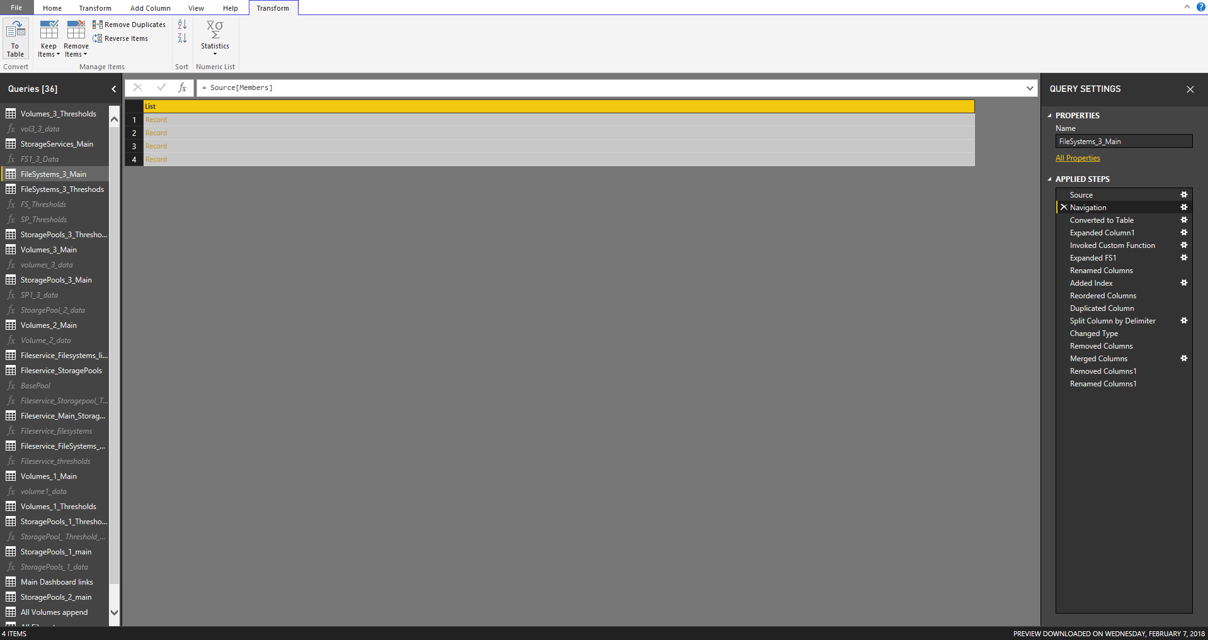

Step15 :-

The above opened list of records will be converted into table as shown in the below figure.

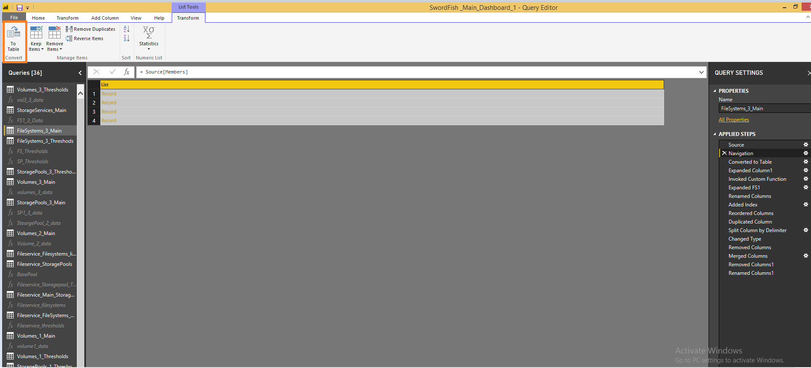

Step 16:-

After converting the table format the records values will expand by double-click on list column.

Below is the all of the expanded URL’s of Sub- Collections like ( Storage Pools, Volumes and Filessystems).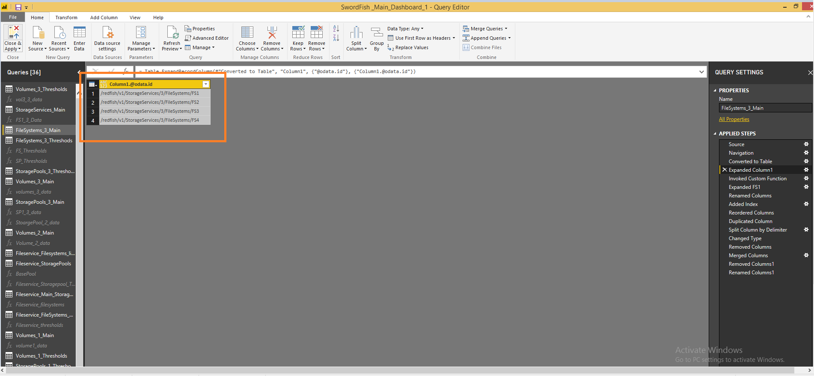

Once Expansion complete ,will invoke the custom function .

**Custom Function** is a query that run by other queries. The main benefit of having a query to run by other queries is that you can repeat a number of steps on the same data structure.

Before we can invoke the custom function will take the one of the (Sub-URL )

in StoragePools

Eg:- <http://localhost:5000/redfish/v1/StorageServices/3/StoragePools/Sp1>

Step 17:-

By using above URL get the Consumed bytes and Allocated bytes by follow Step1 to Step10.1.

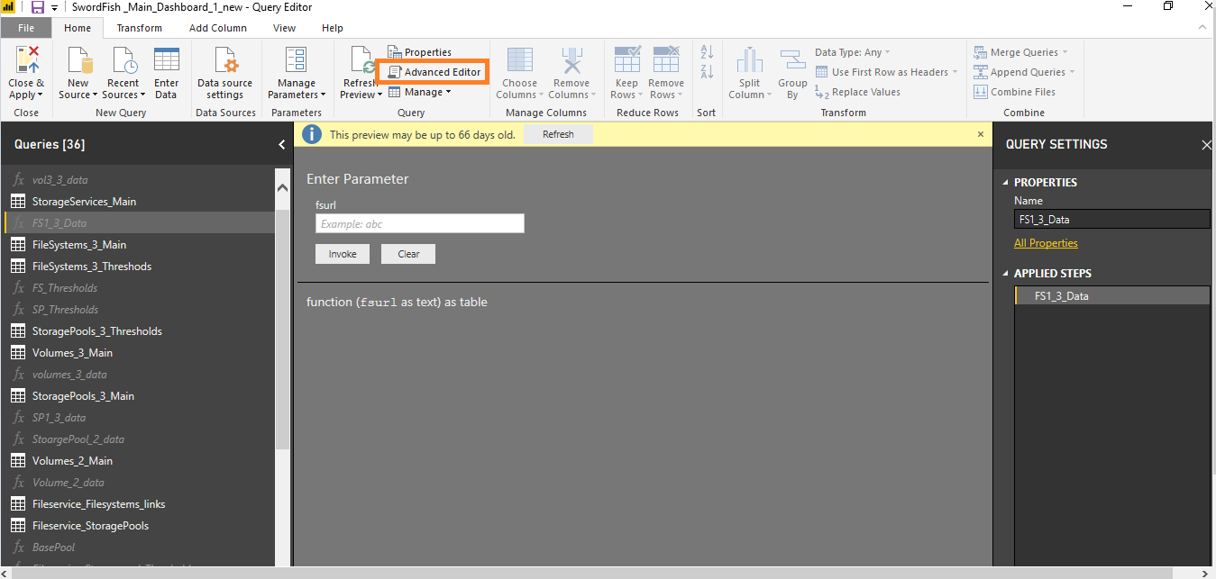

Step 18:-

After follow above steps go to advanced editor button of the following URL

<http://localhost:5000/redfish/v1/StorageServices/3/StoragePools/Sp1>

And write the one line of the query as shown in the below figure

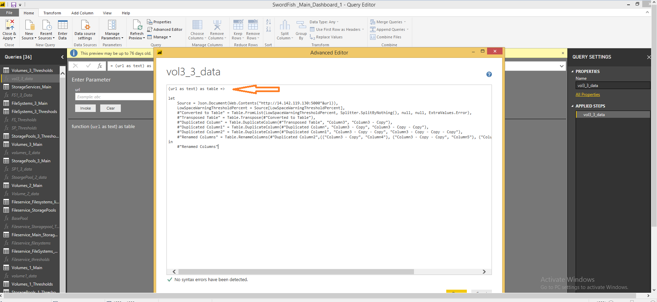

After opening advanced editor window write below query

“----- (URL as text) as table =>”

And Go to Main URL and click on invoke custom function icon as shown in the below figure

Step 19:-

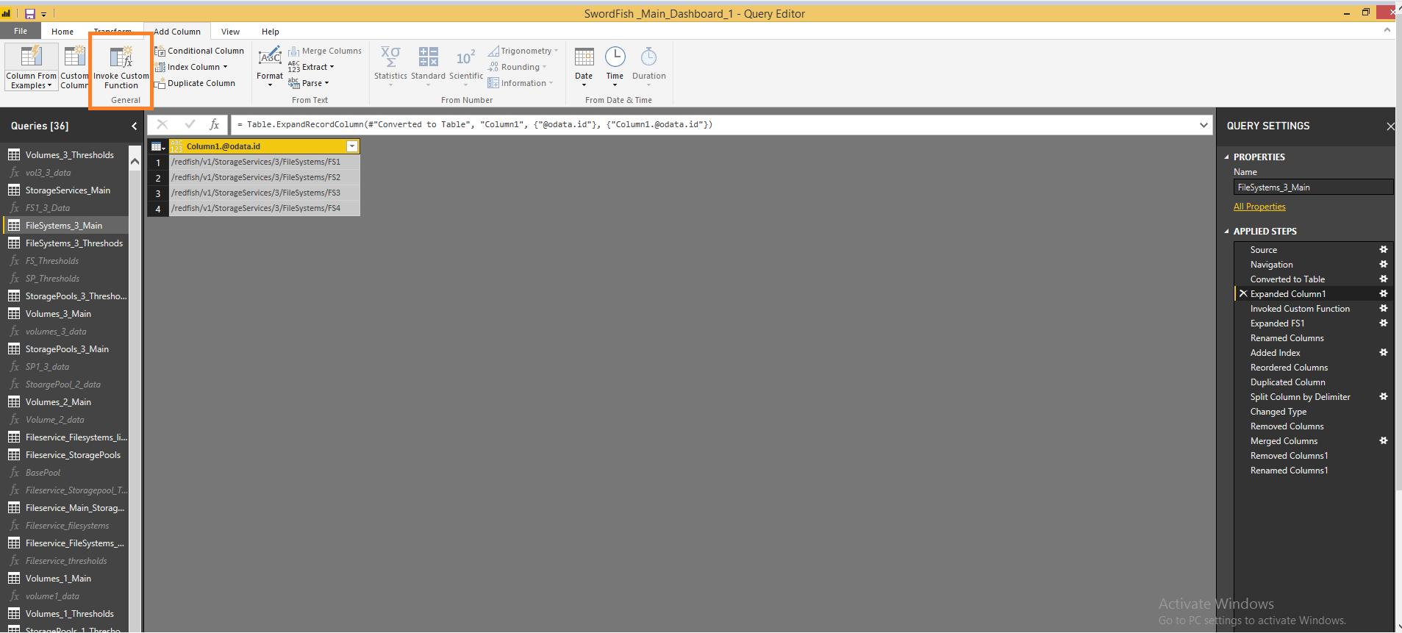

Now invoke custom function the page will come as shown in the below figure

Step 20:-

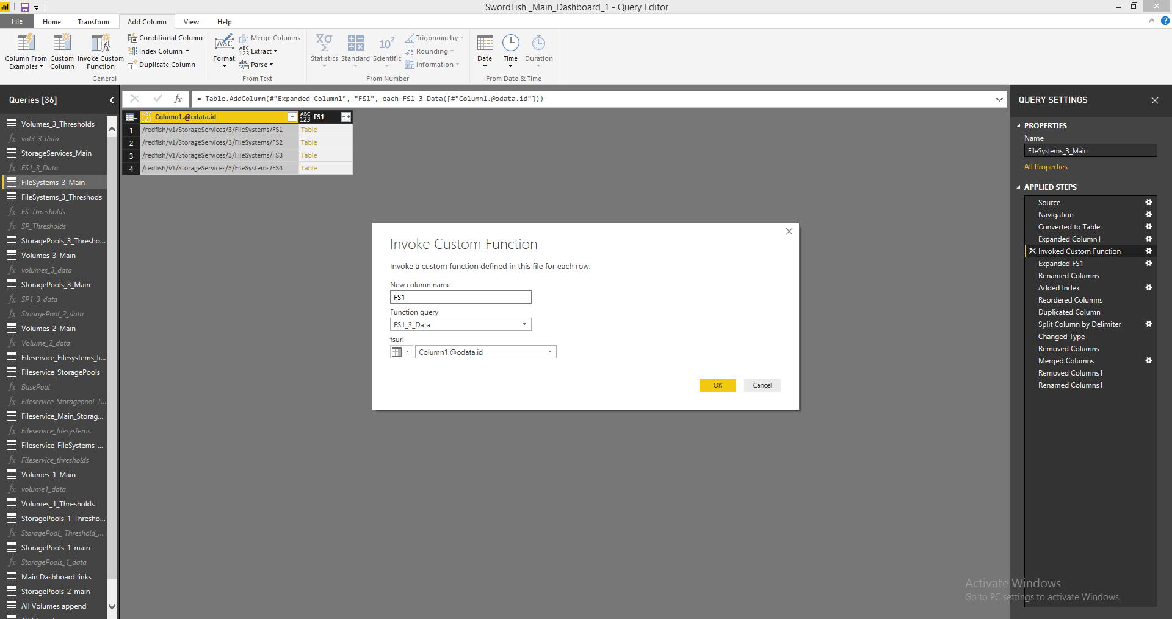

It will ask about which one will invoke into this particular URL ’s Related above Main URL and click ok button

. Step 21:-

Once done expand the column by clicking FS1 column icon it will invoke the all the URL’s Consumed Capacity and Allocated Capacities are mapped as shown in the below figure.

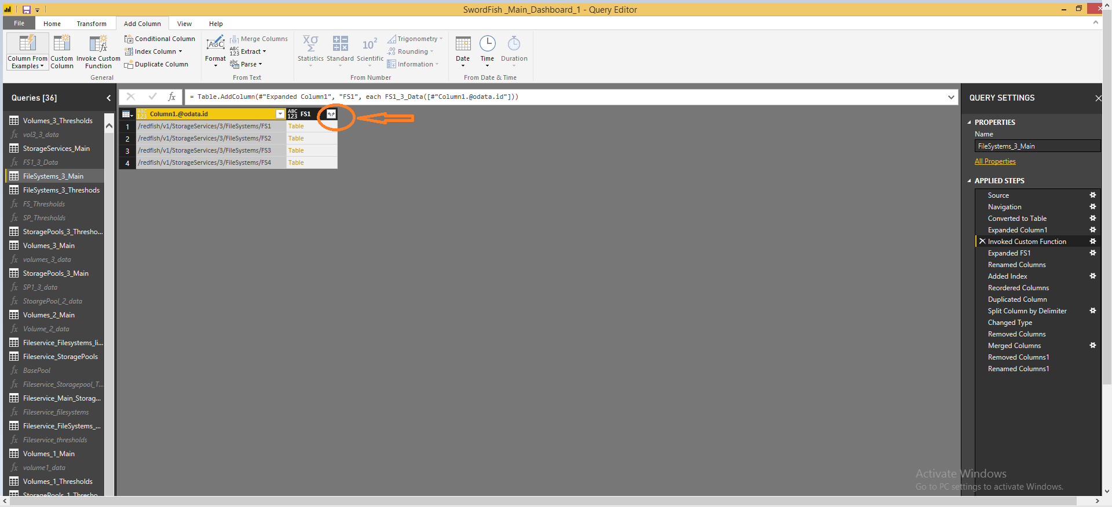

Step 22:-

All the URL’s will expand and mapped into each one capacities as shown in the figure.

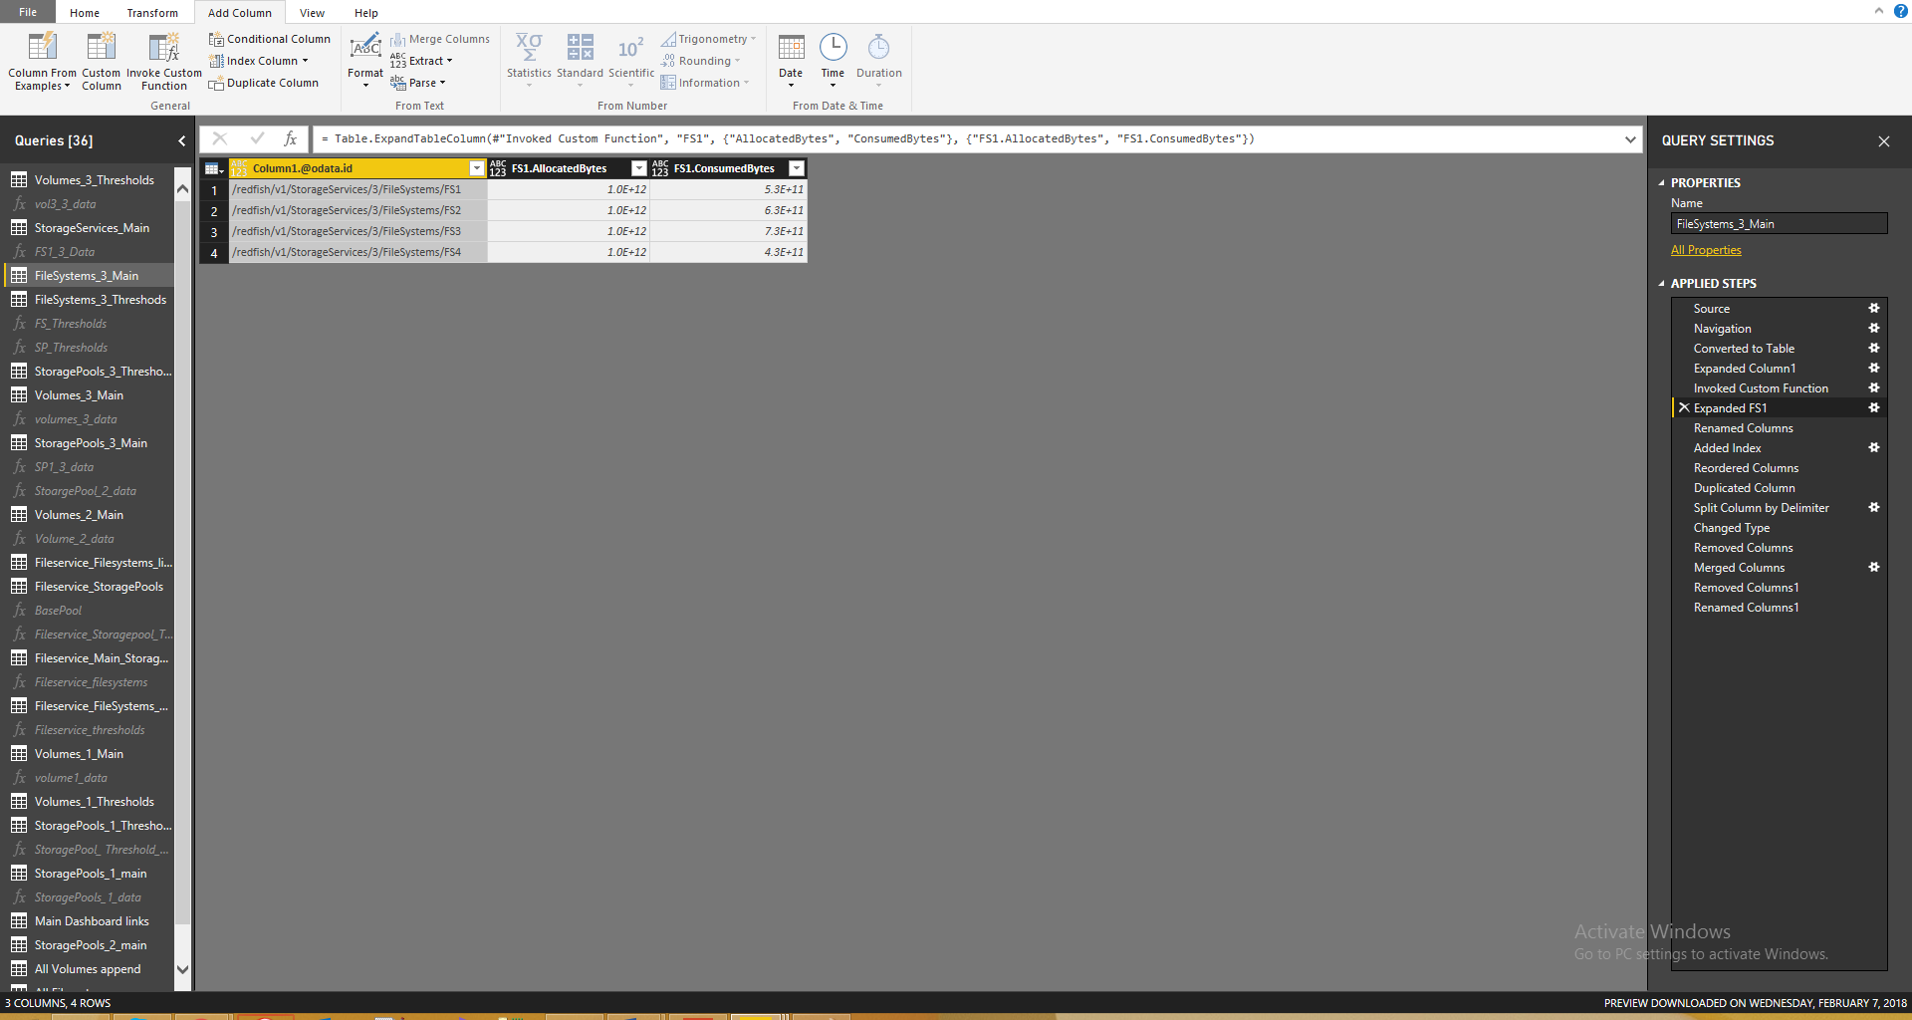

Then Rename the columns as user understanding perspective.

Step 23:-

click the “close &Apply “button as shown in the below figure

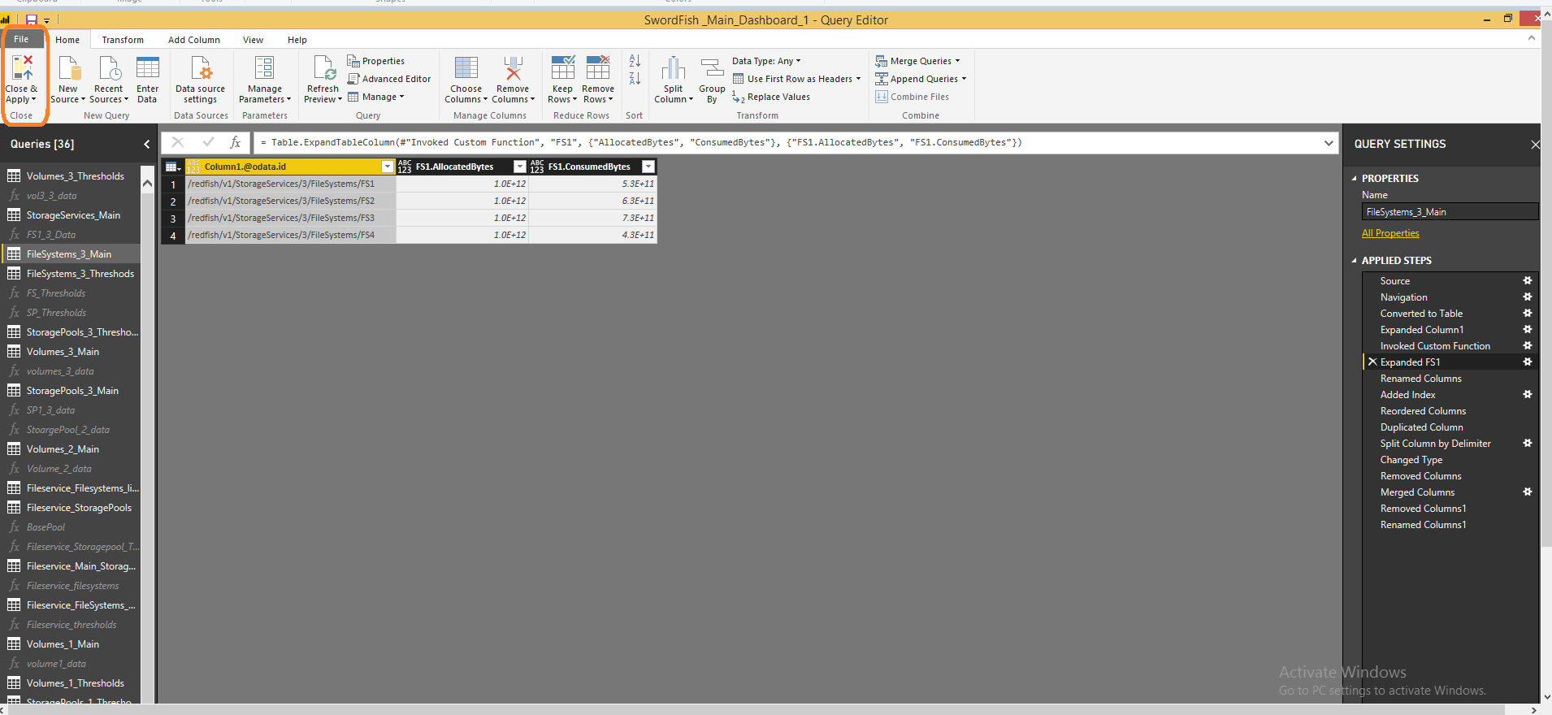

by clicking the “close&apply” button the Main page will come as shown in the below figure.

Step 24:-

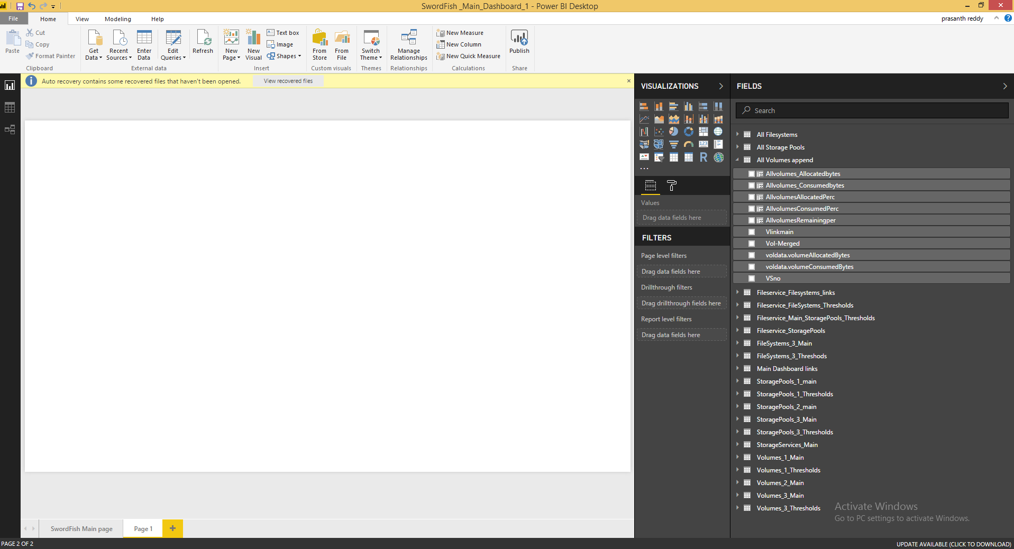

There after we calculated the capacity in bytes converted to terabytes and also calculated the percentages by using following formulae

Allocatedbytes = FileSystems_3_Main[FS1.AllocatedBytes] * (1024*1024*1024*1024)

Consumedbytes = FileSystems_3_Main[FS1.ConsumedBytes]/(1024*1024*1024*1024)

fsAllocatedperc = ([FS1.AllocatedBytes]*100)/[FS1.AllocatedBytes]

fscalcnsumedperc = ([FS1.ConsumedBytes]*100)/[FS1.AllocatedBytes]

After converting the can take chart in visualization explorer and give the values and storage Pools links

Step 25:-

The below are the all Stoarge Pools URL’s Merged data

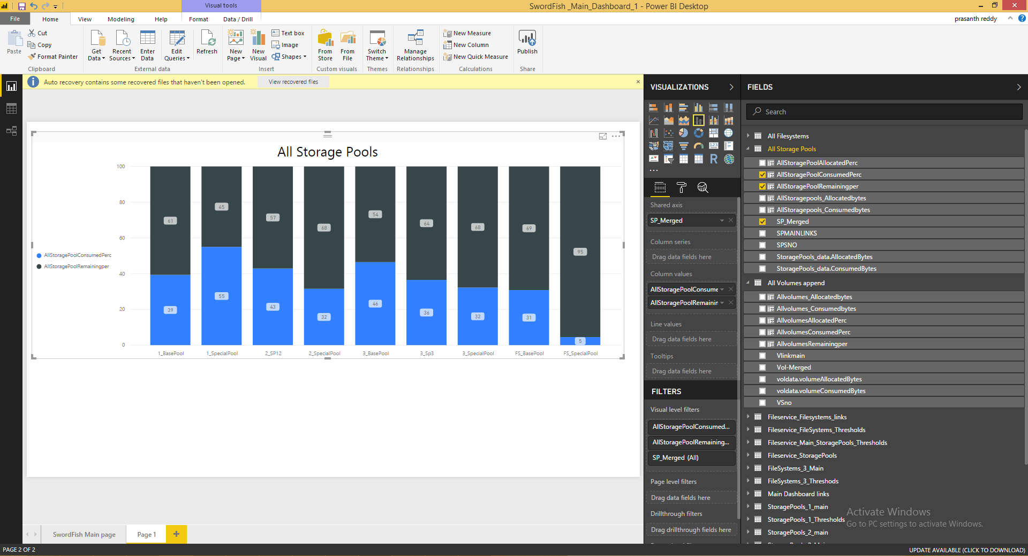

Follow same process for all the Dashboards will get the below Main Dashboard.

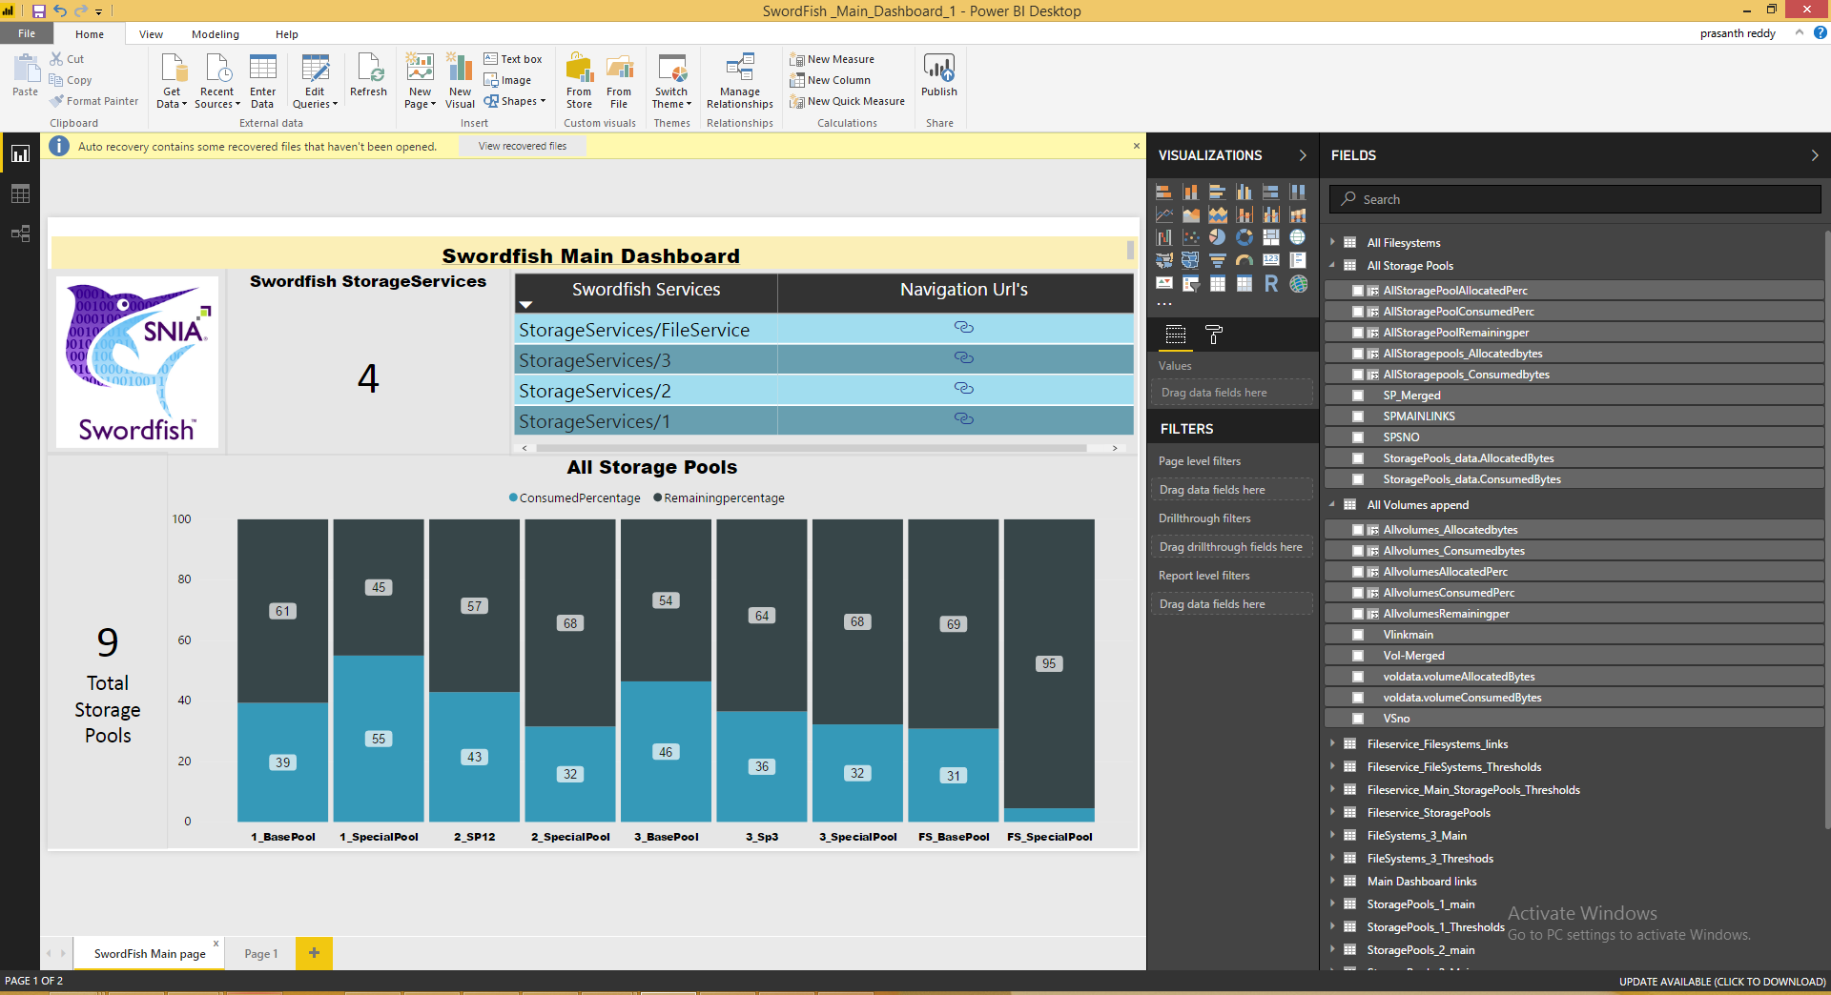

**Fig:- Main Dashboard.**

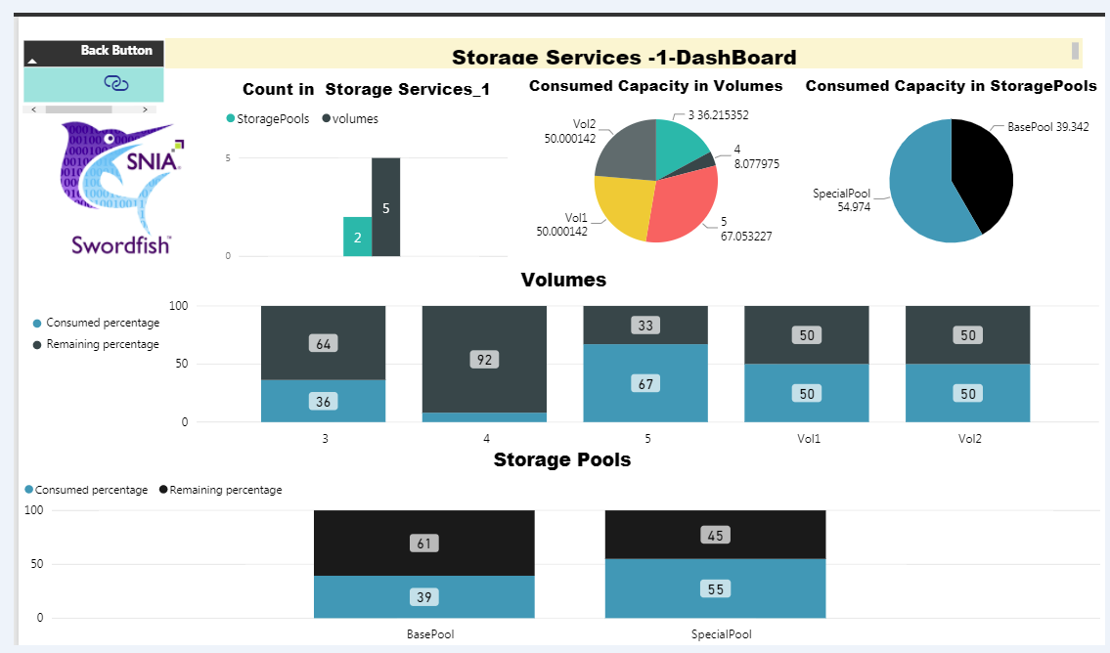

**Fig :- Child Dashboard**

So ,we can create different dashboards for all services by following above all steps.